Rationale Document for the Logical Data Model
Ground-Warfighter Geospatial Data Model (GGDM) version 2.1
APPENDIX –Data Modeling
November 17, 2011

Report Date: November 17, 2011

Contract No W5J9CQ-11-D-0005 Task Order 0007
Unclassified

SAIC, Geo-Spatial Technologies & Information Division

Author:
Annette Janett Filer, SAIC

Contributors:
Robert (Bob) Gaines, SAIC
Dr. Dale D. Miller, SAIC
Dr. Barry Schimpf, Zekiah Technologies, Inc
Nancy Towne, U.S. Army Geospatial Center

Prepared for:
U.S. Army Geospatial Center (AGC)

Document Revisions:
- November 17, 2011 GGDM 2.1

Table of Contents
1. Data Modeling 1
2. Logical to Physical Development Process 3
Component Models 3
GGDM LDM 3
Resulting Logical Data Model 5
Logical Model Transformation to Physical Specification 6
Attribute Information 6
Physical Data Model 6
Allocation of Features to Levels and Groups 6
Allocation of Features to Groups 7
3. Physical Specification 8

Acronyms
This document may make use of several acronyms. We provide them for reference.

AGC Army Geospatial Center
AGDM Army Geospatial Data Model
CDMF Common Data Model Framework
DCS Data Content Specification
EC Entity Catalog
Esri Environmental Systems Research Institute, Inc.
GGDM Ground-Warfighter Geospatial Data Model
LDM Logical Data Model
MCDB US Marine Corp Topographic Production Capability Database
NAS NSG Application Schema
NCGIS National Center for Geospatial Intelligence Standards
NFDD NSG Feature Data Dictionary
NGA National Geospatial-Intelligence Agency
NSG National System for Geospatial Intelligence
PDM Physical Data Model
SME Subject Matter Expert
TDS NGA Topographic Data Store
TGD Theater Geospatial Database
GPC Geospatial Planning Cell
UML Unified Modeling Language
USMC U.S. Marine Corps

Data Modeling
Features can conceptually be thought of as a class or an entity with a geospatial constraint of geometric type. Geospatial feature types generally include: point or node or junction, area or surface or polygon, and line or curve or polyline or edge. Features are assigned attributes or properties; atomic units of information implemented as columns in a table of a database. Attributes have constraints including data type, unit of measure, scale, and allowable domain values. Logically, attributes can have a notion of cardinality to indicate the physical presence of more than one attribute, but physically the attributes must each have a unique name.

In the physical geospatial model, feature types are typically implemented as relational database tables. In some cases, a group of features may be combined to form a set of features (a feature class in an Esri physical model) and this set of features is implemented as a single table. In this case, all of the attributes from all features within the group are combined into a single unique set; these are the attributes found in an Esri feature class. A common misconception is the attributes in a feature class are available to any feature in the group. This is not the case. Even though all attributes are shown to the operator (depending on the tool used), only the attributes defined for a particular feature are valid for that feature.

Relationships between features are specified in the logical model as needed. Relationships specify feature groupings, feature to feature associations, and feature hierarchies. It is worth noting that while relationships are flexible and powerful in the logical model, there may be significant limitations in the physical implementation of relationships. Implementation of a large number of physical relationships can often hinder performance significantly. The data modeling team must consider physical implementation options when developing the model and the tools that transform the logical to physical model. While there are several relationships included in the Ground-Warfighter Geospatial Data Model (GGDM) Logical Data Model (LDM), the physical implementation does not include specific relationships between features for performance reasons.

Logical models provide for packages and diagrams, typically using the Uniform Modeling Language (UML). Packages are used to group features in a UML tool. Diagrams provide for a graphical description of the features, attributes, constraints and relationships. The GGDM includes a UML representation of the model. However, given the GGDM consists of 600 features, no hierarchical relationships, and each feature is related to several metadata entities and several “configuration levels”, a UML diagram of the GGDM is difficult to use. Even so, our release documentation does include the UML for the GGDM.

Model normalization is a process by which representation is simplified to eliminate redundancies, e.g., factoring complex tables into multiple, simpler tables. Normalization is important because it has an impact on efficiency, data integrity and understandability of the data. There are several well defined levels of normalization: first normal form through sixth normal.
- The normalization level for efficient human review and understanding of a data schema may be different than the normalization level required for efficient data access in a physical data environment.
- An understanding of the target platform requirements with respect to data normalization needs is an important consideration in the development of the data model. Pure Relational Data Base Management Systems (RDBMS) have different system requirements with respect to acceptable levels of normalization than geospatially enabled database systems. Even within geospatially enabled systems, different levels of normalization can be considered depending on the specific geospatial system targeted.
The priorities for the GGDM development are a) developing the GGDM such that automated tools can translate the logical model into a physical representation and b) developing a model consistent with the component models and TDS. Given these priorities, the GGDM is developed at or near the first normal form in order to optimally, efficiently, and accurately allow for transformation between a logical state and a physical state, where the physical implementation is currently based on Esri technology. First normal form essentially means every entity has a set of primary attributes and each attribute is single valued. (Some consider that allowing attributes with cardinality greater than one violates first normal form.)

Automated data modeling tools are instrumental in the development of the GGDM. Given the number of data schemas, data requirements, the complexity of the data schemas, the mappings involved, and the general nature of geospatial data content, the use of interactive modeling tools to lay out every feature, attribute, and attribute domain value in UML would require more time. Therefore, the focus of the automation is to:

  - extract data requirements from exemplary data set templates, schemas or data specifications
  - build logical model frameworks from collections of data requirements
  - help SMEs and data modelers with adjudication, ensuring consistency, and review of the model
  - translate the model from logical to physical form
  - generate physical models of multiple formats and styles

The efficiency of this approach was demonstrated by the rapid turnaround of the TDS 3.0 data specification (July 2010) into the AGDM 2.0 release (September 2010). A three month turn-around for integration of data content specifications into logical and physical models for a project this complex was possible with the use of automated tools.

Figure 1. (content within boxes is not meant to be readable) contains UML diagrams illustrating varied levels of abstraction present in a model. The left diagram is the most abstract and depicts hierarchical relationships, component relationships and associative relationships between the entities. The center diagram (part of the GGDM Logical Model) depicts associative relationships. The right diagram depicts a physical model of groups of tables with no relationships.
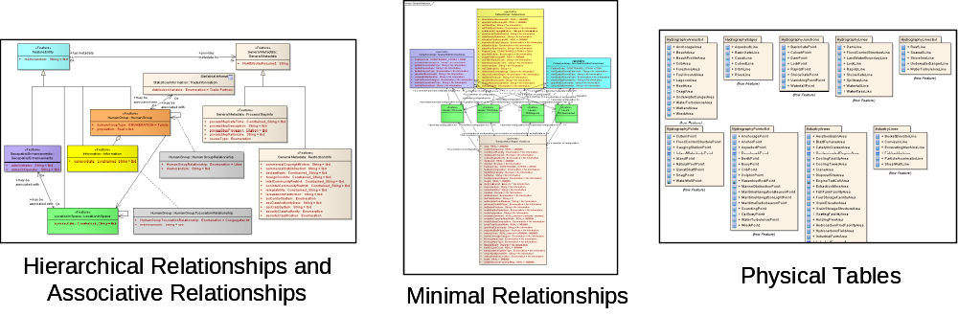
Figure 1. UML Sample Diagrams

Logical to Physical Development Process

The GGDM development process is shown in Figure 2.
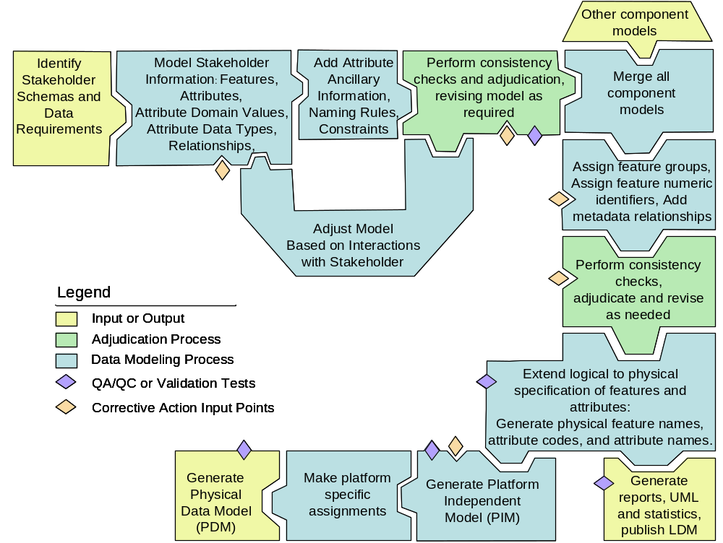
Figure 2 GGDM Development Process

Component Models
The top row of the process is performed for each component model contributing to the GGDM. In some cases modeling stakeholder information as a CDMF compliant LDM is easily done, in other cases the stakeholder information has to be mapped and modeled. The mappings involve dictionary concepts, schema information, and data modeling constraints along with SME input and significant checking and double-checking and adjustments over time. For more detailed information on the mapping efforts, refer to “GGDM 2.1 RationaleAppendix Concept Mappings.doc”. The Rationale documents for MCDB and TGD may also be consulted to better understand the mapping efforts. Once a CDMF compliant LDM has been created that represents the stakeholder information, ancillary attribute information and naming rules are added to generate a “physical specification” used to generate the PDM and comparable to the TDS DCS EC. Additional details regarding this “physical specification” and the process of assigning ancillary attribute information can be found in “GGDM 2.1 RationaleAppendix Physical Data Model”. The consistency processing step on the top row depicts consistency checks and adjudication performed on the component data model. There are additional conformance checks performed on the GGDM not applied to the component models.

GGDM LDM
Upon completion of a baseline set of component LDMs and validation of each component model, all of the component models are merged together into a single LDM . Semi-automated tools are used to assign feature groups, feature numbers, and perform consistency corrections and integrity corrections both at the component level and on the final LDM to ensure the model is complete, correct and accurate. Corrective action/consistency tools used are documented extensively in “GGDM 2.1 RationaleAppendix Consistency”. They are summarized as follows:
- Add the OTH Specified Domain Values(s) attribute to all features where required. This is based on evaluation of the TDS, and information from AGC SMEs that determined this attribute was required and needed to be applied consistently based on known TDS application rules.
- Add the MEM Memorandum, RCG Resource Content Originator, RX4 Resource Owner-Producer, RX3 Resource Non-Intelligence Community Markings, and RS0 Resource Classification attributes to all features except Spatial and Non-Spatial Metadata. These attributes were applied consistently as per TDS application rules. Metadata is known to be an important concern to many of the GGDM stakeholders and these attributes provide for basic metadata.
- Apply the UFI Unique Entity Identifier to all features except dataset as per TDS consistency rules.
- Add the Feature Code attribute (i.e., F_CODE) and feature code value (e.g., AL013 [Building]) to all features as per Esri physical format build requirements.
- Examine features to ensure attribute vector consistency and attribute value consistency across all geometries having the same feature code. Attributes and attribute values were propagated to features of different geometries as needed to ensure this consistency.
- Examine attribute data types, units, scale, and attribute upper bound cardinality for correctness and updated as necessary.
- Add logical model relationships between all geometric features and metadata features where necessary.
- Evaluate the model for incomplete or missing relationships that specify feature levels and feature groups, making corrections when needed.
- Generate feature subtype identifiers based on the TDS 4.0 Thematic Groups with the addition of the characters Pnt / Crv / Srf representing the geometry Point / Curve / Surface respectively.

Upon completion of all consistency/corrective actions, the model generation was completed using the logical model translation tool to translate all logical representations of features, attributes and values into a physical specification. The logical form for attributes includes the base attribute code, a minimum and maximum cardinality, and a data type that includes “interval” data types. The physical form expands the attribution, allowing for correct representation in the physical model. The physical translation will result in a) attributes having cardinality greater than one replicated correctly (with distinct attribute codes); and b) attributes having data type of “interval” expanded into three interval specific interval values (upper value, lower value, and closure type). An Entity Catalog form based on the physical attribution is shown below.

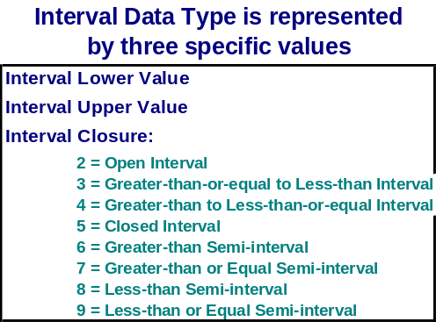
Figure 3 Interval Data Type

The final step in creating the LDM is to generate the overview reports, statistical results, and UML:
- Overview reports are generated showing non-graphical feature, attribute, domain value and relationship information.
- Statistical information is exported into a document, listing the number of features, attributes, values, and the statistics based on lineage statements for each feature, feature attribute, and feature attribute value.
- A Unified Modeling Language (UML) formatted model is generated and a few representative diagrams are created.
The majority of this work is completed with automated tools.

Resulting Logical Data Model
The GGDM model has no hierarchical relationships. The relationships that exist in the model are to: a) associate features to their groups (simple non-hierarchical groups); b) associate features to configuration levels; and c) associate features and metadata entities. Unified Modeling Language (UML) representations are included as part of the release, however they are difficult to interpret as illustrated in the following sample diagram showing the Road feature in UML. The first row of grey-shaded entities represents the metadata entities present in the model. The second row of green-shaded entities represents the configuration level entities in the model (and everything in this in this diagram relates to them), and the bottom entity is an example of one geospatial entity in the model. The diagram does not show:
a) The explicit relationship between the Road Line feature and the TransportationGround group. The name of the entity is TransportationGroundCrv : Road, because this relationship is represented in the UML using a package.
b) Relationships to enumerated domain value lists. The enumerated domain values are typically represented in the UML as entities holding the unique domain value lists.
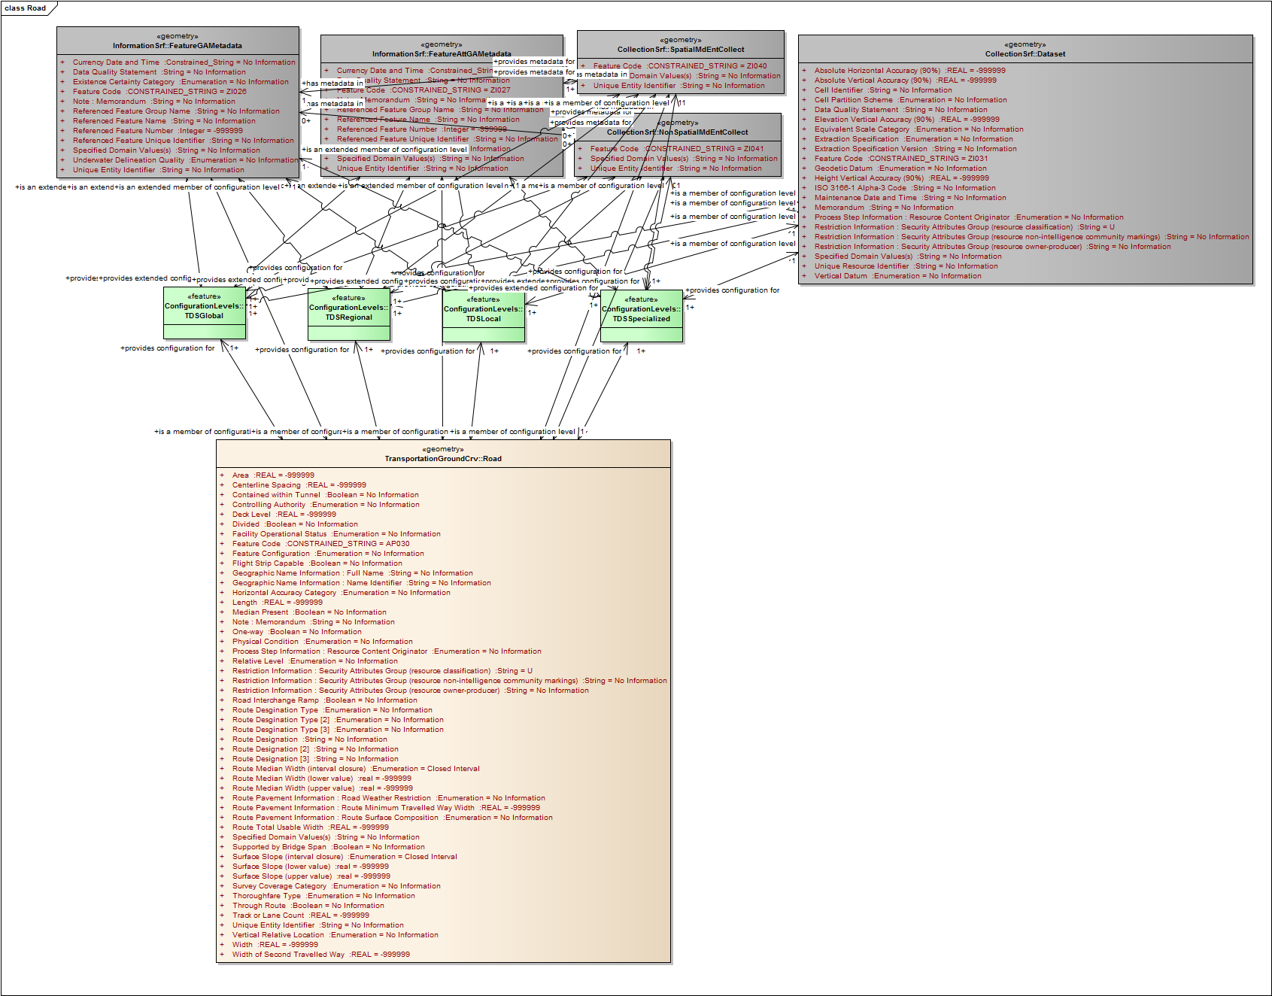
Figure 4. UML of Road Line/Curve from GGDM

The reports associated with the LDM release show a summary of the GGDM features and attributes along with a detailed report listing features, attributes, default values, allowable domain values, and relationships. These reports show the model at the logical level meaning interval attributes are shown with a single entry having the interval data type, and attributes having multiple cardinality are shown with one entry and an upper bound for the attribute cardinality.

- Summary of Features and Attributes – GGDM 2.1 LDMReport_FeaturesAttributesSummary.pdf
- Features Attributes Allowed Values and Relationships –GGDM 2.1 LDMReport_FeaturesAttributesDefinitionsAllowableValues.pdf

Logical Model Transformation to Physical Specification
Within the LDM, a translation in which the attributes are propagated into a form comparable with the TDS DCS EC is included (the GGDM Entity Catalog). The transformation process is described in Appendix B. In the transformation the attributes are expanded into a physical specification. For example, a logical attribute having the data type of “Interval” is expanded into the three attributes required to represent the interval. The expansion of attributes also assigns codes and names to each physically specified attribute so they are unique to the feature and match the TDS.

“GGDM 2.1 Entity Catalog.xls “ shows the model as an entity catalog.

Attribute Information
The data types found in the GGDM include:
- Real Interval - translated into Upper Bound, Lower Bound, and Closure Type
- Integer
- Real
- String
- Constrained String

Units are specified where applicable; otherwise the GGDM includes the statement “Unitless”.

String lengths are specified in the GGDM for all string data types. A string length of “2147483647” indicates a string of unlimited size. Some physical database implementations will constrain the string length to something less than unlimited.

Physical Data Model
The GGDM Physical Data Model (PDM) is constructed using the CDMF compliant LDM and a toolkit developed by Zekiah Technologies, Inc. The process and detailed description of this PDM generation is described in “GGDM 2.1 RationaleAppendix Physical Data Model”.

Allocation of Features to Levels and Groups
Each feature is allocated to one or more configuration levels that correspond to the four data densities described in the Topographic Data Store (TDS) subsection in the Components section. The TDS component provides the baseline set of configuration levels and the allocation of features to configuration levels based on the input from GGDM stakeholder components. The allocation of features to levels is one of the stated requirements from stakeholders meaning that a stakeholder might require a particular feature in levels beyond those specified by the TDS. The GGDM development team has not performed consistency reviews, or general adjudication to the feature assignments to levels and have accepted stakeholder requirements “as-is”.

The assignment of features to levels is described in the Entity Catalog. When the cell value states “IN_TDS” the entity is found in the TDS and in the GGDM in the feature group. When the cell value states “EXTENDED” the entity is not found in the TDS and is in the GGDM in a feature group shown at the left with the characters “Ext” as a suffix:

Table 1. EXAMPLE - Allocation of Features to Configuration Levels
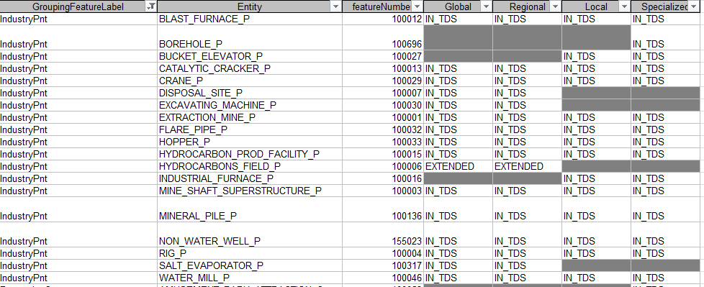

Allocation of Features to Groups
The implementation of TDS makes use of “feature classes” as groupings to gather “feature subtypes”.

The primary purpose of allocating features to feature groups is to provide for maximum potential database synchronization of the GGDM to the TDS. Previous data synchronization tests with TDS implementations indicated extended GGDM features (those not in the TDS) must be placed into new feature groups and the same feature groups and feature numbers be used in the GGDM implementation as the TDS implementation.

The secondary purpose of the feature groups is to improve the performance of the physical implementation. Performance improvements from this organization occur due to a reduction in the number of physical tables in the database.

NGA and AGC have formed a working group to examine, revise, and develop feature group names and feature subtype numeric identifiers used in TDS 4.0 and GGDM 2.1 to ensure synchronization. The feature group names in the TDS 4.0 EC allow for six extra characters: a) three characters of geometry: Point -> Pnt, Curve -> Crv, Surface -> Srf; and b) three characters for implementer usage. The GGDM uses the last three characters to indicate when a feature group contains extended, non-TDS content with the suffix “Ext”.

To summarize, the feature group allocation has been developed as follows:
- GGDM features found in TDS 4.0 are allocated into baseline feature groups with the group name having a suffix indicative of the geometry: Pnt, Crv, Srf (representing Point, Curve, and Surface).
- GGDM features not found in NGA TDS 4.0 are allocated into extended feature groups. These extended groups have the suffix “Ext” in the group name.

Physical Specification
The GGDM 2.1 has a logical model and a physical specification. The physical specification is how they are translated from one to the other.

The abstract LDM is transformed into a physical specification to:
- Allow for direct comparison tests of the LDM and the TDS DCS EC specification for validation. The abstract GGDM LDM is not directly comparable to the TDS, requiring transformation to allow for automated comparisons with the TDS.
- Provide for consistent and accurate (with respect to TDS DCS EC) codification and labeling of the features and attributes for the physical model. Usage of the abstracted LDM content to automatically generate consistent codes and labels for concepts is necessary to have a physical representation. Whether the terms are common or extensions with the TDS DCS EC, the GGDM codes need to exactly match the TDS DCS EC codes. The complexity of the process requires this process to be done in the LDM as a transformation from the logical model into a more physical specification. The goal was to implement the approach in a manner that would give the GGDM content the consistent look and feel of the TDS.

The GGDM is based on the NSG Feature Data Dictionary (NFDD) so the interaction between the TDS DCS EC and the NFDD is important. The TDS DCS EC contains many features and attributes easily matched to the NFDD, and many other attributes that are not easily matched to the NFDD making it non intuitive to decode the complex TDS DCS EC attribute codes. The Canal feature is a good example of this.
  - The Canal feature is easy to interpret because the feature code is provided and the feature geometry is given. The feature code provided in the TDS results in a name mismatch with the feature name provided in the DCS and the NFDD. The GGDM data dictionary was modified to conform to the TDS DCS EC.
  - The Canal feature attribute UFI matches an attribute code in the NFDD as “Unique Entity Identifier” matching the TDS DCS EC property name. In the GGDM logical data model, the attribute UFI has a cardinality of 1, no “prefix” or “postfix” values, and no associated features or attributes.
  - The Canal feature attribute ZI024_HYP is a six-character “prefix”: “ZI024_” and the NFDD code “HYP” (Hydrologic Persistence). The prefix ZI024_ corresponds to a related feature: Water Resource Information. The logical model will capture the attribute code: HYP, the prefix: ZI024_ and the related feature as ancillary information: Water Resource Information (which could be determined from the prefix in this case, but that is not always the case). This attribute has a cardinality of 1.
  - The Canal feature attribute BH141_AWBA is defined as “Waterbody Bank (1): Above Water Bank Slope (first bank)”. The first six characters are a prefix: “BH141_”, but the attribute code is unclear as to AWBA, WBA, or AWB. The attribute has multiple cardinality with a “postfix” character on the property code that indicates the ordinal position - in this case “A”. So the baseline attribute code here is “AWB” which corresponds to Above Water Bank Slope in the NFDD. In this example, BH141 is not “Waterbody Bank” but is “Inland Waterbody Bank” in the NFDD – so either the TDS DCS or the NFDD is in error. This entry in the TDS DCS results in the LDM attribute AWB being specified with a prefix of BH141_, a postfix of “A”, and storage of the related feature “Inland Waterbody Bank”, and a cardinality of 2
  - The Canal feature attributes BPWHAL, BPWHAU and BPWHAC all have a prefix value of a single character “B” which corresponds to the same related feature BH141 “Waterbody Bank” (that should be “Inland Waterbody Bank”). The base attribute is PWH “Predominant Waterbody Bank Height” with two postfix values: “A” which indicates the ordinal value of an attribute having multiple cardinality, and “L”, “U”, and “C” used to represent the the data type “Interval”. The six values in the TDS DCS with a single logical attribute that has a cardinality of 2 and data type of Interval with a prefix “B” and a postfix value is coded as “A” for the indication of multiple cardinality, while a secondary postfix value is coded as “[I]” to indicate this Interval attribute requires special handling needed to represent an Interval attribute.

http://en.wikipedia.org/wiki/First_normal_form

